IP Project Work (2025-26)
- The aim of the class project is to create tangible and useful IT application.
- The learner may identify a real-world problem by exploring the environment. e.g. Students can visit shops/business places, communities or other organizations in their localities and enquire about the functioning of the organization, and how data are generated, stored, and managed.
- The learner can take data stored in csv or database file and analyze using Python libraries and generate appropriate charts to visualize.
- Learners can use Python libraries of their choice to develop software for their school or any other social good.
- Learners should be sensitized to avoid plagiarism and violation of copyright issues while working on projects. Teachers should take necessary measures for this. Any resources (data, image etc.) used in the project must be suitably referenced.
- The project can be done individually or in groups of 2 to 3 students.
- The project should be started by students at least 6 months before the submission deadline.
PROJECT MUST BE
REALISTIC (Experiential / Field visited)
UNIQUE
STUDENTS’ OWN CREATION
SYLLABUS INCLUSIVE
ART INTEGRATED
This project report must be well organized with clear details about project work.
The fonts must be standard fonts.
Proper layout must be maintained.
Show your arts creativity and skills as much as possible. But avoid exaggerated look.
Submission: After final approval of the code and report from the teacher, printed copy of project report to be submitted in stripe file / card board file / clip file.
Some sample projects:
- Hospital management system
- Stationary shop management system
- Fabric printing factory’s management system
- Students management system
- Ticket booking system
- Park Entry Ticket System

PROJECT DOCUMENT FORMAT (SUGGESTED) STARTS FROM NEXT PAGE >>>

--PROJECT TITLE--

Prepared by
--stud 1— (CBSE Roll No.)
--stud 2— (CBSE Roll No.)
Class XII – Sc/Comm.

For the partial fulfilment of
AISSCE – 2025-26

Guided by:
Mr. Dhiren K. Meshvaniya
PGT-CS, PM SHRI KV Jetpur

Submitted to

PM SHRI KENDRIYA VIYALAYA JETPUR

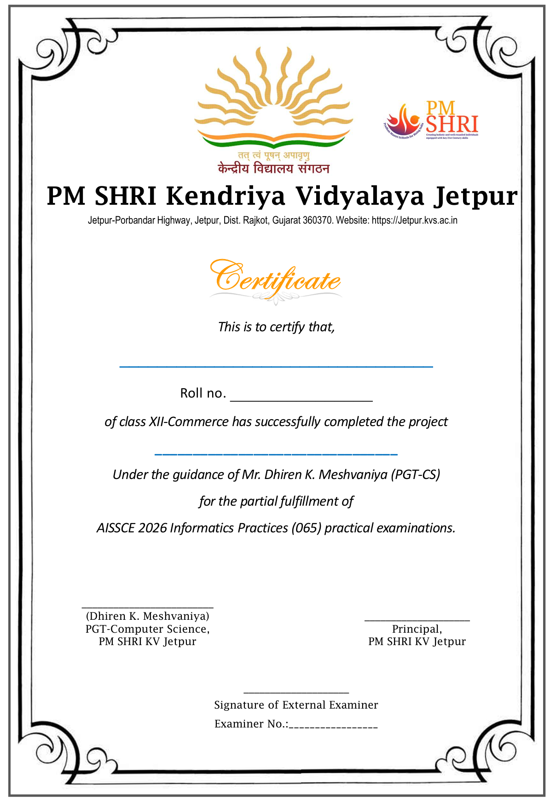
Index
- Index
- Acknowledgement
- Project Definition
- Project Scope
- Project Benefits
- Project profile
- Technologies used & System Requirements
- System Implementation
  - Database
  - Source Code
  - Screenshots
- Limitations
- Conclusion
- References

(all chapters in index must have page numbers)

Acknowledgement

<<your opinions about acknowledgements>>

--
Student1 name
Student2 name

Project Definition
--few lines about your project—

Project Scope
-- Where your project can be used and how --

Project Advantages
-- List the benefits of using your project --

Project Profile
Title :
Application :
Technologies used : Python (including Pandas, Matplotlib)
DBMS : --MySQL/CSV--
Other Tools : MS Word, Notepad++, IDLE, Excel, any other…whatever used
Developed by : --stud1 name— (CBSE Roll No.)
--stud2 name— (CBSE Roll No.)
Guided by :
Submitted to : PM SHRI Kendriya Vidyalaya Jetpur
Session : 2025-26

Technologies Used
1. Python
--few lines of introduction--
--benefits--
--disadvantages--

2. MySQL/CSV
--few lines of introduction--
--benefits--
--disadvantages--

System Requirements
Hardware:
Processor: _____
RAM : ___GB
HDD : ____GB
Software:
Development : IDLE/Jupyter NB/Spyder/G.Colab/…
OS :
DBMS : MySQL/any other

System implementation
- Database description
- Code
- Screenshots of each menu/page/feature/output etc

Limitations
-Few limitations of your software

Conclusion
- What you learnt
- What benefits you got from this project work
- Summary of your project

Bibliography
  - List of books you used for learning for this project
  - Format:
    - <Author name>, “<book title>”, <publisher>
Web references
  - List of websites you used for learning for this project

* * * * *

